Query all attributes of every Japanese city in the **CITY** table. The **COUNTRYCODE** for Japan is JPN.

The **CITY** table is described as follows:  
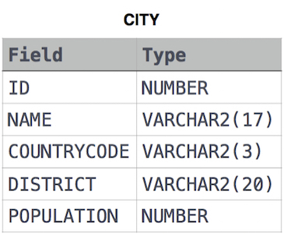

**Ans:**

Select * from CITY where COUNTRYCODE=’JPN’;